**Big Mountain Resort Capstone Project**

Muj Qasim

**Introduction**

Big Mountain Resort, a ski resort in Montana, wanted a data driven approach to ticket pricing and future investment strategies. Specifically, they wanted to know how their features (i.e., chair lifts, vertical drop, number of runs, etc.) influence ticket prices within their market in order to determine what to build, what to retire, and if they could raise their ticket price without spending more. They provided data in the form of a CSV from resorts that they determined shared a market space with Big Mountain. We used this data to model ticket prices in relation to key features.

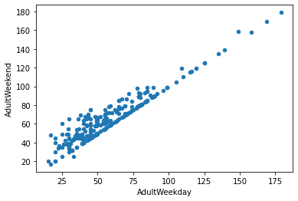**Identifying Key Features and Variables**

First, we wanted to know which ticket price we would be focusing on. The data set included both Adult Weekday and Adult Weekend prices. After establishing that the two were strongly correlated, we examined which were missing the least number of entries and decided to go with Adult Weekend tickets.

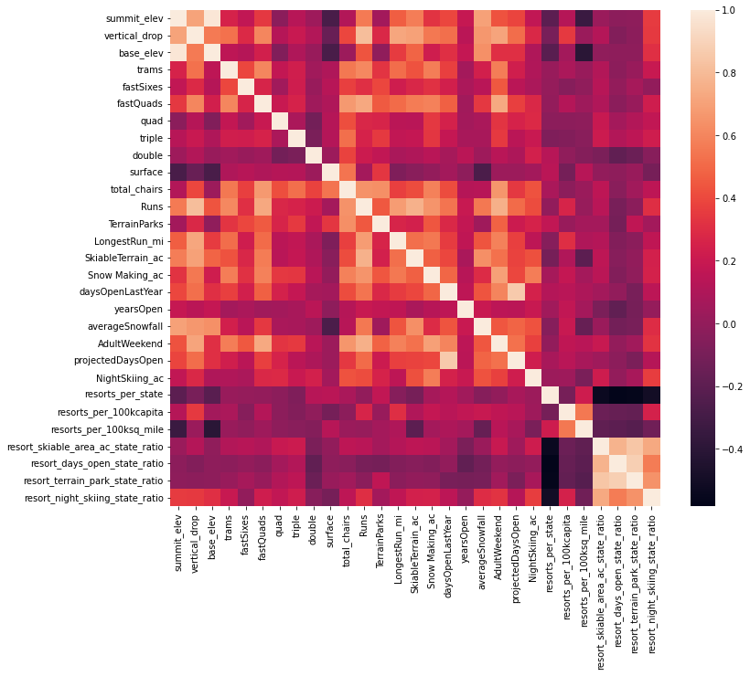Early data analysis was performed using Seaborn and Scikit Learn (sklearn) packages to find which variables were correlated with one another. Our heatmap of the variables in the data (below) showed Adult Weekend prices were reasonably correlated with number of fast quad lifts, number of runs, and the acreage covered by snow making machines. The implication we took from this was that visitors valued guaranteed snow coverage over area that could potentially have snow, and the ability to get to runs quickly.

**Preprocessing and Training**

We started with a 70/30 Train/Test split for our data and reduced both sets to just their numeric features. First we modeled the data using only the mean. Our Mean Absolute Error (MAE) for predicted ticket price from this model was $19. We tested this against a linear regression model and a Random Forest, and found the latter had the best performance with a MAE for ticket price of only around $9. The Random Forest also identified, fast quads, total runs, snowmaking acreage, and vertical drop as the most important features of importance.

**Modeling**

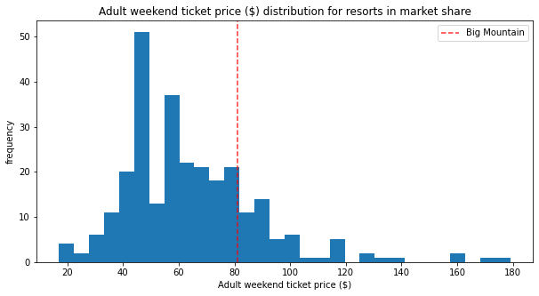 Once we established which model we wanted to use, we took a look at Big Mountain Resort for where it places in its market context. Big Mountain has one of the highest Adult Weekend ticket prices in Montana, and one of the more expensive in the country.

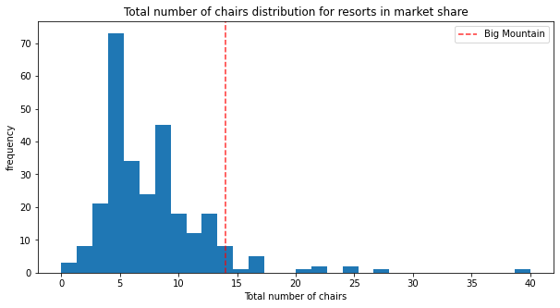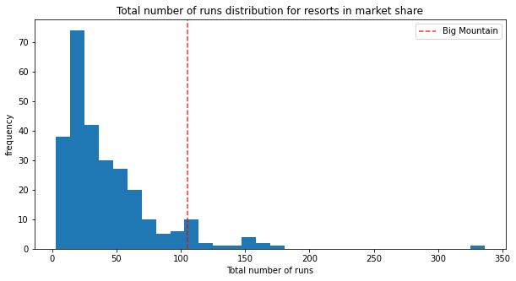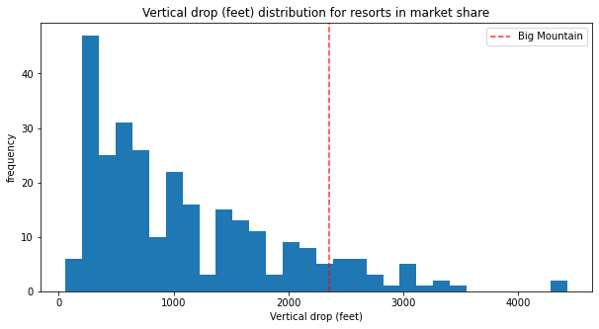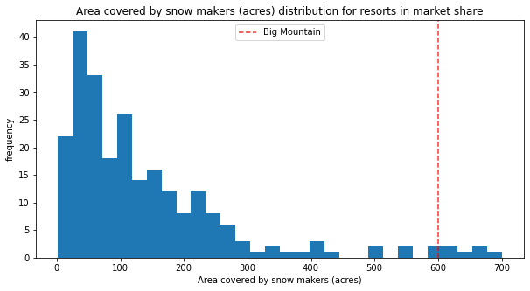 However, Big Mountain is also comfortably on the higher end of key features like vertical drop distances, area covered by snow makers, number of total chairs, number of fast quads, total runs, and distance of longest run. Without making any changes, the resort’s estimated ticket price was $95.87. With a MAE of $10.39, even being extremely conservative this implies Big Mountain could justify raising prices from $81 by $4.48.

**Modeling Scenarios**

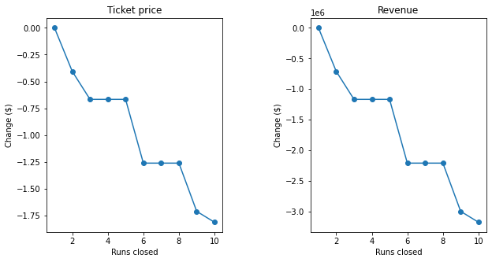 Big Mountain shortlisted some options: closing up to 10 of the least used runs, increasing the vertical drop 150 feet requiring an additional chair lift, the same but adding 2 acres of snow making coer, and increasing the longest run by 0.2 miles requiring an additional 4 acres of snow coverage.

Revenue was projected to decrease no matter how many runs were closed, however we found interesting clusters that the business could use to determine how many to close. Closing 3 to 5 runs and closing 6 to 8 runs had the same effect on ticket price.

In the second scenario, we modeled that the resort would add 1 run, increase the vertical drop by 150, and build a chair lift. The scenario supported an increase of ticket price by $1.99, amounting to $3,474,638 more in revenue over the season.

The third scenario was similar to the second but we added the addition of 2 more acres of snow making coverage. There was no meaningful increase in ticket price over the second scenario. Similarly, the fourth scenario, in which the longest run was extended by .2 miles and snow making by 4 acres, no difference was seen in ticket price.

**Conclusion**

We concluded that Big Mountain’s current ticket price is underpriced for the national market when based off of the features the resort offers. Of its shortlisted business options, adding a run and increasing the vertical drop was predicted to be the most successful. In general we found that small, incremental increases in snow making coverage, despite being identified as an important feature, did not make a meaningful impact on ticket price.

We lacked the data necessary to make a conclusion on whether Big Mountain should be judged nationally, on a region-by-region basis, or just within its state. Without more information on where its visitors are coming from, we decided to model it against national trends, since there was more data available.

Without knowing the maintenance, removal, and installation cost of individual features, we leave it up to the resort to determine the best investment strategy, but in general we suggest focusing on number of runs, lifts, specifically fast lifts, and guaranteed snow coverage.